F1 ANNUAL EXAMINATION 2021
LINDI REGION
PHYSICS MARKING SCHEME
1.
i | ii | iii | iv | v | vi | vii | vii | ix | x
B | B | C | B | B | C | A | B | C | D

2.
i | ii | iii | iv | v
B | D | F | H | I

3.
- Floating
- Force acting and cross-section area
- Friction
- Laboratory
- Fundamental force
4. a)Pressure is the force acting normal per unit area, SI unit of pressure in Newton per Meter square( N/M²) or Pascal.
b) Pebbles have sharp edge which means small area since Pressure$=\frac{force}{area}$ , therefore the area is less while Pressure is more. That’s it is painful to work barefooted on a road covered with pebbles.
c)Data given
force (F) =30N, maximum area(A_{max}) =50m², minimum area(A_{min}) =20m²
i) Maximum pressure =$\frac{force}{minimum area(Amin)}$ $\frac{30N}{20m2}$ 1.5N/m²
ii) Minimum pressure = $\frac{force}{maximum area(Amax) }$ $\frac{30N}{50m2}$ 0.6 N/m²

5. a) i/ Regular reflection ii/ Irregular reflection
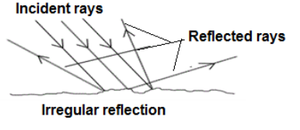
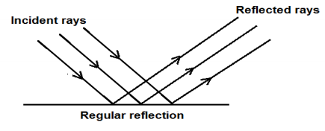

b) i/ i⁰=$\frac{(180-80)}{2}$ $\frac{100}{2}$ = 50⁰
ii/ r⁰= $\frac{(180-80)}{2}$ $\frac{100}{2}$ = 50⁰ or r⁰=90-40 = 50⁰
c) i/ $\frac{360}{⊖}$ -1 $\frac{360}{90}-1 4-1=3$ images
ii/ $\frac{360}{⊖}$ -1 $\frac{360}{60} -1 6-1=5$ images

6. a) Physics is the study of matter in relation to energy,
- Enable us to answer several questions /solve problems
- Enable us to design and manufacture items like generator, transformer motors etc
- Help us to acquire different professional like doctor, engineering, architecture, etc
- Help us to help others example the use of machine and giving first aid to victims
- Enable us to enjoy since we study practically
b) i/in medical field -
x-ray, ultrasound machine and microscope made due to knowledge of physics
ii/at home
door handles, steam iron ,electrical cooker, car jack, pulley they use knowledge of physics
iii/at school
Instruments and apparatus used in laboratory created by knowledge of physics
Iv/ in transportation and communication
Devices like computer, newspapers, car, aero plane, ship, telephone, discovered and works under the principles of physics
v/in entertainments
physics helps people to enjoy example photography, exercise machine,etc
vi/ in industry
Machinery and tools are made and operates by using knowledge, principle and skills of physics
vii/help us to construct source of energy like batteries, bulbs, uses knowledge of physics
c) there is no distance moved.
Since work done(W.D)= Force (F) X distance (d), now because distance is zero therefore , work done is equally to zero.
7. a) Force is the pull or push experienced by an object, SI unit of force is Newton (N).
b) .i/ electromagnetic force
ii/ gravitational force
Iii/strong nuclear force
iv/ weak nuclear force
c) Laboratory is the special room where scientific experiments are done /conducted or
is the working room for scientists
d) i/ thermometer ii/ beaker
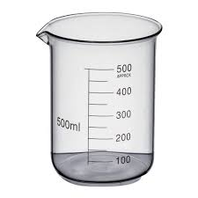
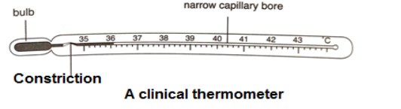

8.a) energy is the ability to do work.
- Nuclear energy
- Light energy
- Chemical energy
- Heat energy
- Sound energy
- Mechanical energy
- Solar energy
b) i/ Potential energy is the energy processed by the body due to its position while kinetic energy is the energy due to the motion of the body
By the formula potential energy= mass x gravity x height while kinetic energy = (mass x velocity square )/2
ii/ data given
Mass (m)=5kg, velocity (v)=4m/s, kinetic energy=?
Kinetic energy (K.E)=MV²/2 (5 X 4 X 4)/2 = 40J.
9.a) i/ the floatation law states that;
“a floating body displace its own weight of fluid, in which it float’’
ii/ Archimedes principle states that;
‘‘when the body is totally or partially immersed in fluid it experience an up thrust equals to the displaced fluid’’
b) i/ data given
Weight in air(R)=5N apparent weight (A)=3N up thrust ( U)=?
Up thrust = (R-A) 5N-3N = 2N
Relative density (R.D) =(R/U) 5/2 = 2.5
C) Relative density of ship is less than relative density of water. At the same time relative density of coin is greater than relative density of water,
Also the submerged area of ship is large and wide enough compared to that of coin, that’s why ship float on water while coin sink in water

10. a/
- steam iron
- ballpoint pen
- batteries
- door handles
- car seat belt
- walking
- cell phones
- headphone/earphones
- Spinning
- Washing machine
- Camera lens
- Alarm clock
- Doppler radar
b)
- Size and shape of image and objects are the same
- Distance from image to mirror and distance from object to mirror are the same
- Angle of incident is equal to angle of reflection
- Image is virtual/not real
- Image is upright
- Image is inverted
c)
- Solid - example iron, wood, timber, bone
- Liquid - example water, oil,
- Gas- example oxygen gas, helium gas etc.

