PHYSICS WEEKLY TEST SERIES 01
CHITA SECONDARY SCHOOL
Fill $the blanks by writing the correct answer in the space provided$
$\left(i\right)……………………………….is defined as any substance which has mass and occupies space.$
(ii)The shape of the surface of mercury in a clean glass tube$is…………………………………$
$$\left(iii\right)…………………..…in physics simply the process of assigning number to observation or events.$$
$$(iv) Attraction forces between molecules of different substances are known as …………………..$$
$$\left(v\right)…………………….is the force that one surface or object encounters when resting$$
$$or moving over another.$$
5. (a) state:
(i) Archimedes principle (ii) law of flotation (iii)Hookes law (iv) Pascal principle. (v)Ohm’s law
(b) In an experiment to determine the relative density of liquid, a solid Q weighed the following:
Weight in air =8.6N, Weight in water=6.0N , Weight in liquid=5.4N
- Calculate the density of liquid (ii) Calculate the relative density of liquid
06.$(a)List down four uses of hydraulic press.$
$$\left(b\right)Explain why a tractor with wide tyres cannot easily get stuck in muddy places as compared$$
$$to vehicles with narrow tyres.$$
$$\left(c\right)Calculate pressure at the bottom of the sea water of 50m deep. If the density of water is$$
$$1020kg/m^{3}.Take the acceleration due to gravity (g) is 10N/Kg.$$
$$7(a) Differentiate between speed and velocity.$$
$$\left(b\right)A car starts from rest and and is accelerated uniformly at a rate of {4m}/{s^{2}} for 5sec.$$
$$It maintains a constant speed for 20sec, brakes applied and the car stops in the next 3sec.$$
$$(i)Draw a velocity time graph of the motion$$
$$\left(ii\right)Find Maximum speed attained.$$
$$(iii)Find the total distance$$
$$8\left(a\right)What do you understanda about the following terms.$$
  - $Machine (ii)Load.$ (iii)Effort
$$(b) Why efficiency of machine is less than 100\% .Briefly explain .$$
$$\left(c\right)A force of 600N is used to move a load of 3000N Up an inclined plane .Given that$$
$$the slanted height and vertical of the plane are 18m and 3m respectively. Find$$
$$(a)Velocity ratio of the plane ,(b)Mechanical advantage,(c)Efficiency of the plane.$$
$$9 \left(a\right)How do you understand by the term$$
$(i)Inertia$ $\left(ii\right)Momentum \left(iii\right) Impulse$
$$(b)State Newton’s second law of motion$$
$$\left(c\right)A 4Kg object is moving to the right at{2m/s}^{} when it collides elastically head on$$
$$with a stationary 6Kg object ,after the collision the velocity of the 6Kg object is$$
$$1.6m/s to the right. Find (i)Velocity of 4Kg after the collision$$
$$\left(ii\right)Total kinetic energy before and after collision$$
$$10(a) (i) what is the function of ammeter in an electric circuit.$$
$$\left(ii\right)List four factors that affect the resistance of a conductor.$$
$$(b)Study the circuit diagram in the figure 1 below then answer the question that follow;$$

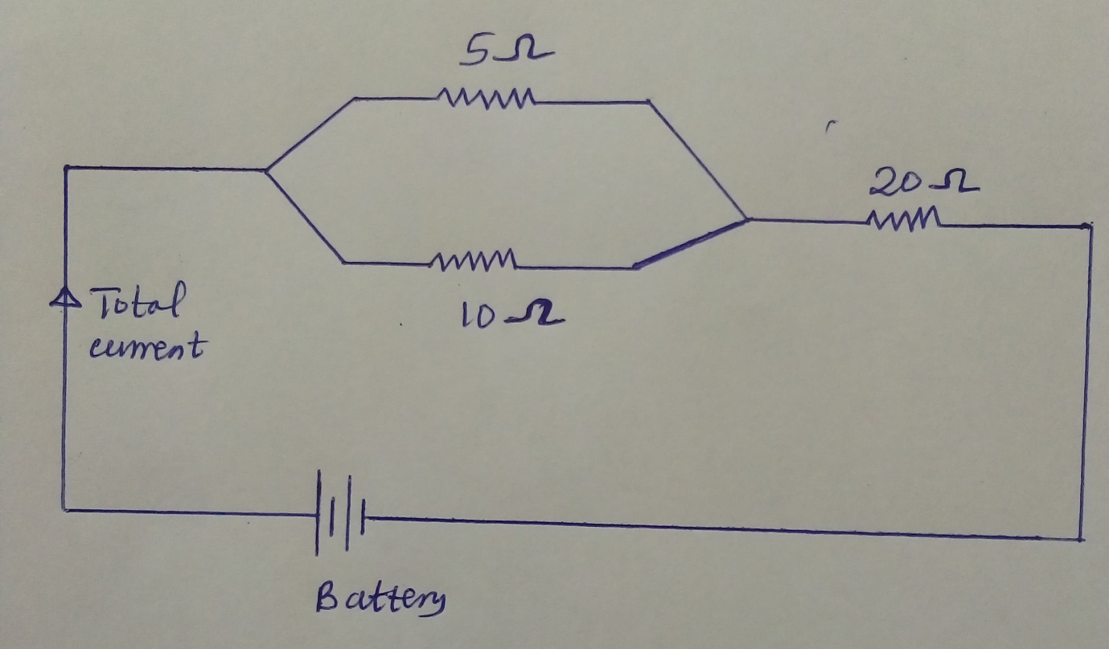

$If the current flowing in 5Ω resistor is 2A; Calculate the \left(i\right)Current flowing in 10Ω resistor$
$$\left(ii\right)potential difference \left(P.d\right)across the 20Ω resistor$$

