CHITA SECONDARY SCHOOL
FORM TWO MONTLY TEST 2
PHYSICS MARCH 2023
- (a) Give reason for the following explanations
- Water wet the walls of its container but mercury does not
- Antiseptics used for cuts and other wounds have a low surface
- A blotting paper is used to soak ink
- Small insects are able to run about on the surface of water without
sinking
(b) Calculate the height of a turpentine oil barometer when mercury barometer
stands at 76cm. Density of mercury = 13,600kg/m³, density of turpentine oil =
0.8g/cm³
(c) Explain briefly why a fountain pen taken in a high-flying aero plane leak

- (a) i. Distinguish between capacitor and capacitance.
ii. list the types of capacitors that you know and their uses.
iii. mention appliances that use capacitors.

(b) 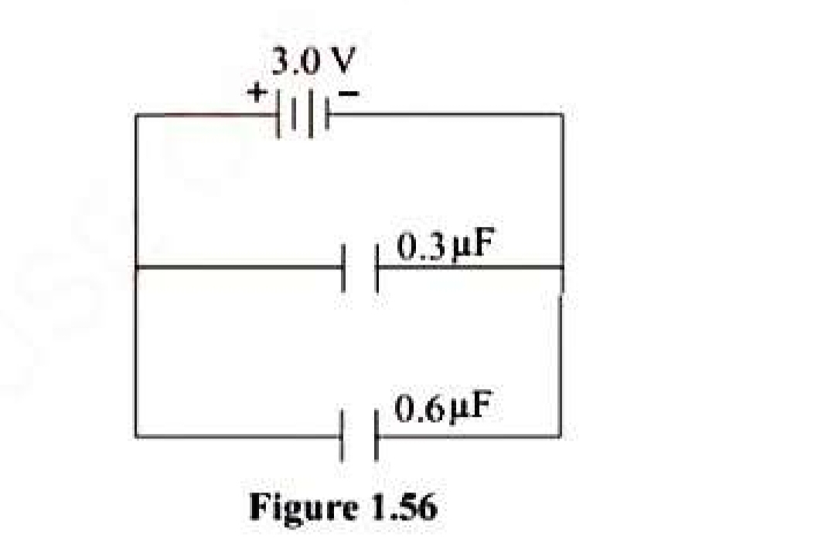
i. determines the effective capacitance of the circuit.
ii. how much charge is stored?
c). Draw a well labeled diagram of gold leaf electroscope.
3.(a). An object thrown vertically upwards. Which of the following could be equal zero when it reaches its Maximum altitude?
(i)Displacement (ii)Velocity (iii)Acceleration
Explain your answers.

