PHYSICS TEST SERIES 3
CHITA SECONDARY SCHOOL
TIME:1HR
- . Answer this question by filling the correct answer in the space provided
i. Pressure in liquid normally depends upon ____ and ________
ii. Example of magnetic material is ____ while non-magnetic material is _
iii. The temperature of 660F is equivalent to ______________ K
iv. ___ images are formed when an object is placed between two plane mirrors
inclined at an angle of 900
v. _______________ and _______________ are units of momentum
vi. Laboratory doors should open outward because______
vii. ___________ is a rate of displacement covered
- The symbols represents ……………………
- A sharp needle was brought close to the cap of a charged gold-leaf electroscope.Explain why the leaf collapsed………………
- The tendency of a body to return to its original shape when applied force is removed is known as; ………………………
2. (a) “Physics is life” support this statement by analyzing two points for each of the following scenarios:
i. In Schools…………………….
ii. In hospitals……………………
iii. In agriculture…………………
iv. At home……………….
(b) Akilimali wants to measure dimensions of his house for roofing project. Assist him any two measuring devices he could use so as to fulfill his work.
(c) What causes dust particles and tiny grains of soot to move with Brownian motion?
3. (a) i. State the Archimedes principle (ii) law of floatation
(b)If you add detergent in water, you will find the wetting properties of water
increased on solid surfaces of its containers. This is because
(b) Student measure weight of stone in air as 17.4N. When its weight measured in liquid is
reduced by 7.2N. Calculate the relative density of the stone.
4. (a)Point out the three equations of motion
(b)A car accelerates from a speed of 80(m/s) to a speed of 120(m/s) in 60 seconds. It then moves with this speed for 20 seconds and initially decelerates uniformly to a stop after another 40 seconds. (i)Draw velocity time graph to represent the motion.
(ii)Calculate the total distance travelled by the car.
5. (a) Explain why racing cars should have wide wheel tracks?
(b) Explain the terms mechanical advantage velocity ratio and efficiency as applied to a machine and state the relationship between them
(b) Briefly explain why it is important to keep the Centre of gravity of a motor- bus as low as possible.
c)A uniform rod AB, 2.0 long ,weight 0.40 N ,If weight of 0.80 N and 0.40 N are suspended from A and B respectively at what point will it balance ?
6. (a) With four points explain why water is not suitable to be used as the thermometric
Substance
(b) A force of 2N is applied over an area of 20cm2. Find the amount of pressure exerted
(c) Using Petrol, Fire wood and Charcoal in our daily activities as the source of energy,
creates an environmental destruction. Suggest any four (04) forms of energy to be used while protecting environment.
d)A hydraulic lift has piston with area of 0.02m² and 0.1 m² as shown below .A car with a weight of 5000 N sits on the plat form mounted on a large piston.
DIAGRAM.
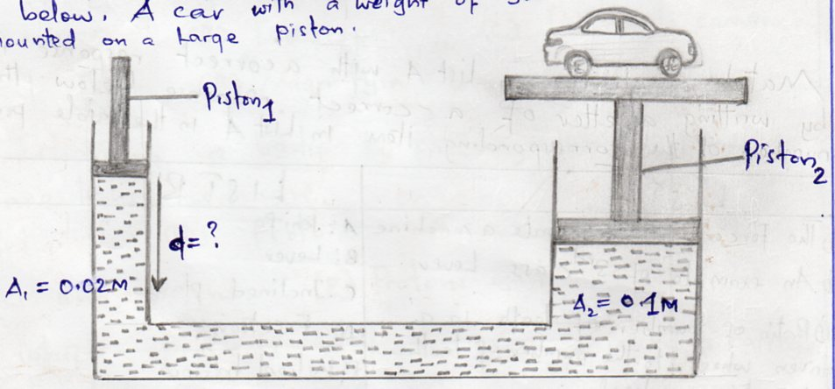

Calculate the force that must be applied to piston 1 to lift the car and the distance that piston 1 must be pushed down ward to raise the car 0.3m?
7. (a) Explain about (i) machine (ii)Load (iii) Effort
(b) Draw the pulley system with velocity ratio 5
(c) i. Give reason why Efficiency of the machine is less than 100%?
ii. A block and tackle system of five pulleys and has efficiency of 86% required to lift a load of 200N. Calculate effort needed to do this.
(b) In which class of level does each of the following device belong?
- Showel ___________________________________________________
- Scissors ___________________________________________________
- Crowbar___________________________________________________
- See – saws_________________________________________________
(c)A force of 600N is used to move a load of 3000N up an incline plane. Given that the
slant height and the vertical height of the plane are 18m and 3m respectively calculate
- The mechanical advantage
- The velocity ratio of the plane
…………………………………………..END…………………………………………………..
…Two people are better than one…>Acclesiastes 4:9-12. Cooperates with your Friend to Solve Problems…… (Sir H.Mwala).

