PHYSICS TEST SERIES 01
School@AllLevel TUTION CENTRE
FORM ONE
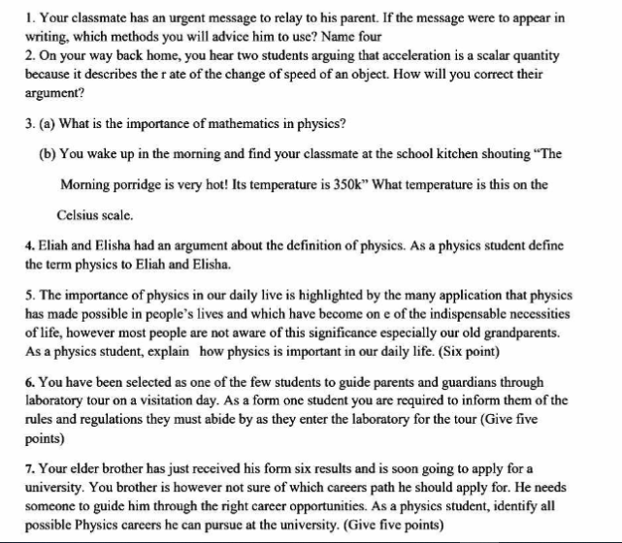
- (a) Briefly, explain the following terms:
- Physics (ii) Matter (iii) Biophysics
(b)Give any two forms of energy and explain how they are usefully in everyday life.
- Describe the common features of science laboratory (5 features)
- What should you do in the laboratory in the event of the following situations?
- your partner brakes a beaker
- you have your Kilimanjaro water and you want to drink it
- you need to carry out an experiment but there is no body in the laboratory
- you want to burn waste paper
- why is it important for all apparatus used in electrical experiments to be thoroughly dried? Explain
- a) what do you understand the term laboratory apparatus?
b) state the uses of the following apparatus in physics laboratory
i) Magnets ii) Ball and ring apparatus iii) Bar braking apparatus iv) slotted masses
………………………………………………………….END……………………………………………………………………….

