PRESIDENT OFFICE
REGIONAL ADMINISTRATION AND LOCAL GOVERNMENT
JOIN THE REVOLUTION PROGRAM
FORM FOUR PRE-NECTA I (2023)
PHYSICS MARKING GUIDE
1.
i | ii | iii | iv | v | vi | vii | viii | ix | x
B | C | A | A | B | A | A | C | B | D
10 Marks @ =1
2.
i | ii | iii | iv | v | vi
A | B | C | D | E | J
6 marks @ = 1
3. a) Vc = 60 cos 60
= 60 x 0.5
= 30N 04 marks
b) The nail is not driven into the wood
Thus
Vc = 60 cos 90⁰ 06 marks
= 0
4. a) i) The boots for soccer and hockey player have studs on their soles this is to avoid slipping during playing. This is because the studs decrease the area of contact between the feet of the player and the ground. As a result, pressure of the feet on the ground increase and the player can run about the ground without slipping.
ii) The force required by man to move his limbs immersed in water is smaller than the force for the same movement in air this is because the upthrust (buoyancy force) on a body is much more in water than that when immersed in air. Therefore, the effective of the limbs of a man is less in water than in air. For this reason, the force required to move his limbs in water is much smaller than the force for the same movements in air.
b) i) Diameter of the base of conical flask (d) = 7.0cm = r 3.5cm = 0.035m
The depth of the liquid (h) = 10cm = 0.1m
Density of the liquid ($ρ_{l}$) = 840kg/m³
Force due to liquid (F) = unknown
Solution
From the formula of force
F = mg-------------(i)
But from density
m = $ρV$--------------(ii)
Where
m = mass of the liquid
$ρ$ = Density of the liquid
V = Volume of the liquid
Then
V = Ah = $π^{2}$h-----------(iii)
Substitute equation (ii) and (iii) to equation (i)
ii) Data given
Cross section area = A
Force = F
Height = H
Density = $ρ$
Required the pressure of liquid = P
Solution
Pressure (P) = $\frac{force(F)}{Area(A)}$
P = $\frac{F}{A}$ ------------(i)
But
F = mg ------------- (ii)
Then
F = p$π$hgr²
F = 840kg/m³ x 3.14 x 0.1m
X 9.8m/s²
X (0.035m)²
F = 3.1664N$≈$ 3.17N
Find the total force due to the liquid on the base in Newton’s 3.17N
m = $ρV$ ----------(iii)
Also
V = Ah --------------(iv)
Substitute equation (ii), (iii) and (iv) to equation (i)
P = $\frac{ρAhg}{A}$
P = $ρhg$
The pressure P exerted by the liquid on the bottom of the cylinder is given as P= $ρhg$
Hence driven!!!
5. a) i) According to newton’s second law of motion,
Force (F) $\frac{Mass \left(m\right)×changein velocity ∆V}{time taken (t)}$ 1 mark
Thereby, a person failing on a cemented floor gets more hurt than a person
failing on a sand floor, because on failing on a sand floor, the time of impact
increase due to depression of sands and this cause a decrease in impulsive force
and hence less hurt 2 marks
ii) According to newton’s third law of motion, for every action, there is an equal but
opposite reaction
Thereby, the hunter moves abruptly backwards because of the reaction force
which is equal but opposite to the action force of the bullet during firing
1$\frac{1}{2}$ marks
b) Data given Efficiency of hydraulic press, $e=90\%$
Diameter of a large cylinder is eight times the diameter of a small cylinder,
D₂ = 8D₁.
Required: Mechanical advantage of hydraulic press, MA
Solution
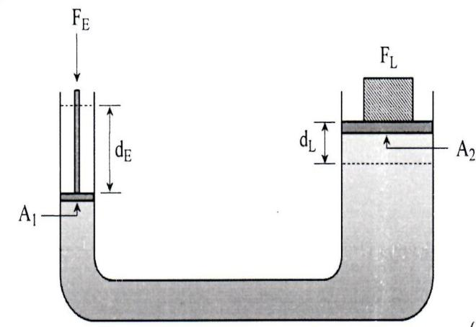

Here, a student is required to draw a well labelled cross-sectional diagram of a
hydraulic press as shown below
Also, a student is required to express the relationship between the cross sectional area of the cylinder and the distance by which it is moved in order to find velocity ratio of the machine.
From the figure, it is clearly that the cross - sectional area of each cylinder is inversely proportional to the distance by which it is moved. That is,
A₁$∝\frac{1}{d_{E}}$
A₁$\frac{K}{d_{E}}$
K = A₁ ^{d}E
A₂$∝\frac{1}{d_{L}}$
A₂$=\frac{K}{d_{L}}$
K = A₂ ^{d}L
Where K = Volume of liquid displaced by either cylinders of the hydraulic press.
This means that, A₁ ^{d}E = A₂ ^{d}L

Rearranging it, we have
$\frac{d_{E}}{d_{L}}$ = $\frac{A^{2}}{A^{1}}$
$\frac{d_{E}}{d_{L}}$ =$\frac{π\frac{{D2}^{2}}{4}}{π\frac{{D1}^{2}}{4}}$
$\frac{d_{E}}{d_{L}}$ = ${\frac{D2}{{D1}^{2}}}^{2}$
Recall that D₂ = 8D₁. Thus,
$\frac{d_{E}}{d_{L}}$ = $\frac{\left(8D_{1}\right)2}{{D1}^{2}}$
$\frac{d_{E}}{d_{L}}$ = $\frac{64D_{1^{2}}}{D_{1^{2}}}$
$\frac{d_{E}}{d_{L}}$ = 64
Since V.r = $\frac{d_{E}}{d_{L}}$, Then
V.R = 64 ½ mark
$e$ = $\frac{M.A}{V.R}$ X 100% ½ mark
$e$ x V.R = M.A X 100%
M.A = $\frac{e ×V.R}{100\%}$
M.A = $\frac{90\% ×64}{100\%}$
M.A = 57.6 1 mark
The mechanical advantage of hydraulic press is 57.6
Total 9 marks

6. a) Use Newton’s second law of motion to deduce that, impulse is equal to the
change of linear momentum of a body, and explain why it necessary
important to fold our legs when we jump from a height on landing 5 marks
Expected response
From Newton’s second law
The force applied F is proportional to the rate of change of linear momentum $\frac{∆P}{∆t}$ Then mathematically,
F $a$ $\frac{∆P}{∆t}$
F = K $\frac{∆P}{∆t}$
Where k = 1 = proportionality constant
F =$\frac{∆P}{∆t}$
F$∆t$ = $∆p$
But F$∆t$ = impulse
Impulse = $∆p$
It is necessary to fold the legs when jumping from a height on landing in order to
extend time of impact of force (increase impulse) in order to reduce pain.
b) A car with cambered wheels cannot overturn instead it will only skids
because the cambered wheels make it very stable. 4 marks

7. a) Heat capacity is the amount of heat required to raise a temperature of a
body by one kelvin WHILE Specific heat capacity is the amount of heat
required to raise unit mass of a substance by one kelvin 2 marks
b) $θ$₁ -$θf$ = $θf$-$θ$₂
$θf$ + $θf$ = $θ$₁ +$θ$₂
$\frac{2θf}{2}$ = $\frac{θ_{1+ θ_{2}}}{2}$ 1 mark
$θf$= $\frac{(25+35)^{0_{C}}}{2}$ 1mark
= $\frac{{60}^{0_{C}}}{2}$
$θf$ = 30⁰C
The equilibrium temperature = 30⁰C 2 marks

8. b) i) An object appears coloured when light falls onto it because the object
reflects light of its colour falling onto it, and it absorbs the rest. 2 marks
ii) Pigment are impure while light is pure. A yellow pigment absorbs blue light and
reflects yellow red and green and a blue pigment absorbs yellow and red
lights and reflect blue and green. When the two are mixed only green light will
be reflected in common blue light and yellow light are complementary colour
they add to white.
5 marks

9. a) The effects of x-rays to human being are
- Destroy cells and can cause cancer
- Can cause mutation due to destroy of genitals
1$\frac{1}{2}$ @ = 3 marks
b) i) X-rays are produced when filament or a cathode which emits fast moving
electrons into a vacuum accelerates from cathode to strike a target with an
anode which some of kinetic energy converted to x-rays

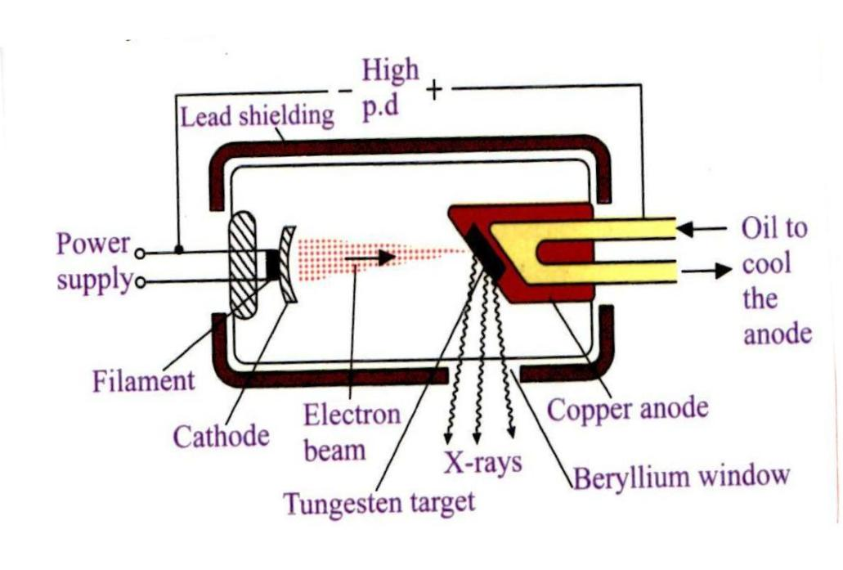

ii) Use of x-ray in daily life are;
- In medical field soft x-rays, used to defect to broken or fractured bones or some disease in soft tissue and treatment of cancer
- Crystallography: experiment study of the arrangement of atom in solid (study of arrangement of crystals)
- Astronomy: x-ray emitted by celestial objects are used observational astronomy
- x-ray microscopic analysis: involves the use of electromagnetic radiation in the soft x – ray band to produce image of very small object
1 @ 4 marks
10. a) Faraday’s law of electromagnetic states that
‘’Whenever there is change in magnetic flux linked with a closed circuit e.m.f induced whose magnitude is directly proportional to the rate of change of the magnetic flux linking the conductor’’ 2.5 marks
Lenz’s law states that
‘’The direction of induced e.m.f is such that the resulting induced current flows in such a direction that oppose the change that cause it’’ 2 marks

b)
 | Name 1 mark @ | Reason 1.5 mark @ | Function 1.5 mark @
i | Step down transformer | Has low number of turns in secondary coil | To step down electricity before used in houses
ii | Step up transformer | Has high number of turns in secondary coil | To step up (increase) electricity from power ststion

11. a) The diagram of cathode ray tube
Cathode ray tube used in
- Computer display
- Television any two 1 mark @
- Cathode – ray oscilloscope (CRO)
Properties of cathode rays
- They travel in straight lines
- They carry negative charges
- They have energy and momentum
- they affect photographic plates any two 1 mark @

b)
Device | Purpose
Diode | To allows current to flow through it in one direction
Transistor | To amplify or switch electronic signals and electrical power
2 marks @

PREPARED BY U.B.N COOPERATION
PHYSICS SERIES
WhatsApp 0624 254 757

