THE UNITED REPUBLIC OF TANZANIA PRESIDENT’S OFFICE
REGIONAL ADMINISTRATION AND LOCAL GOVERNMENT
SINGIDA DISTRICT COUNCIL
FORM FOUR PRE- MOCK EXAMINATION
PHYSICS 1
Time 3:00 hours March 2023

Instructions.
- This paper consists of three section A,B and C
- Answer all question from section A and B only ONE (1) question from section C.
- Write your index number on every page of your answer sheets provided.
- wherever necessary use the following constant
Speed of light $C=3.0×{10}^{8}$m/s
Speed of second in air = 340m/s
Acceleration due to gravity S = 9.8m/s²
𝜋 = 3.14.
Density of water = 1000kg/m³

SECTION A (15 MARKS)
Answer all question in this section
- For each of the item (i) – (x), choose the correct answer among the given alternatives. Each of questions carries (1 marks)
- Diffusion occurs quickly in a gas than a liquid because;
- The liquid contains a layer on its surface
- The gas contain semi – permeable membrane
- The gas molecules is small in size compared to the liquid molecules
- The adhesion in layer than cohesion in gas compared the liquid.
- The speed of molecule in gas is greater than in a liquid.
- In a loading a lorry a man lift boxes each weight 100N through a height of 1.5m, If he lift 4 boxed per minutes the average power the man is working is.................
- 100
- 10
- 600
- 37.5
- 2250.
- In a process of charging by indication in static electricity.
- A conductor is rubbed with an insulator.
- A charge is produced by friction.
- Negative and positive charges are separated
- A positive charge induced a positive charge
- Electrons are sprayed into an object.

- A magnetic needle, free to turn in a vertical plane, is suspended fist at the earth magnetic pole and then a point a magnetic equator. The respective angles between needle and horizontal are,
- 0⁰and 0⁰
- 70⁰ and 70⁰
- 0⁰ and 45⁰
- 0⁰ and 90⁰
- 90⁰ and 0⁰
- The acceleration of a moving object may be found from
- The area under its velocity – time graph.
- The slope of the velocity – time graph
- The area under its distance – time graph
- The slope of the distance – time graph
- The slope of the peak of its distance – time graph.
- The layer in the atmosphere weather phenomena are formed is,
  - Stratosphere
  - magnetosphere
  - Troposphere
  - Thermosphere
  - Exosphere

- Which of these resources of energy is non – renewable?
- wave energy
- Bio fuels
- radiant Energy
- fossil fuel
- Geothermal energy.
- An Electromagnet
- Is made of a steel
- Is made of soft iron
- Is a strong magnet where the current is off
- Has a solenoid of bare copper wire
- Has a solenoid of bare steel wire
- A bus carrying a very big load on its carries can easily overturn because,
- it cannot run fast
- its equilibrium is stable
- Its centre of gravity is low
- It is more stable and can run fast
- Its centre of gravity is high.
- The apparent depth of a certain point at the bottom of water pond is 25cm. If the refractive index of water is 1.3, the real depth is
- 77.5cm
- 35cm
- 30cm
- 32.5cm
- 31.5cm
- Match the items in list A with the responses in list B by writing the letters of the corresponding response beside the item numbers.
Each item carries 1 marks.
LIST A | LIST B
- An instrument used to record ground movement due to earthquake.  - Boundary which separates troposphere and stratosphere.  - Greenhouse gas  - A point on the earth’s surface where earthquake originates.  - Triatomic from of oxygen. | - Nitrogen gas  - Pitcher scale  - Ozone  - Epicenter  - Hypocenter  - Tropopause  - Seismograph  - Lahars  - Carbon dioxide gas

SECTION B
Answer all questions from this section.

- (a) A body dipped in a liquid experiences an up thrust. Explain three factors on which the up thrust depends (4.5 marks)
(b) Two identical free running trolleys are on a smooth horizontal non way. One trolley is at rest and the other approaches it at constant speed of 20m/s.
- Use the principle of conservation of momentum find the common speed of two trolley after collision. (3.5marks)
- Why the kinetic energies before and after the collision are different (2marks)
- (a) A uniform half meter rule is balanced at 15cm mark when a load of 0.4N is hanging at the zero mark. Draw a sketched diagram indicating the arrow of weight of the rule through the centre of gravity hence determine the weight of the half meter rule (5marks)
(b) A screw jack has a screw pitch of 5mm and the effort arm of 16cm
- State two form of energy in which the energy supplied to the screw jack is finally converted to (2marks)
- Determine he percentage efficiency of this screw jack, If it needs an effort of 30N to lift a load of 75N. (3mark)
- (a) state one example of the use of a convex mirror and indicate why it is preferred to a plane mirror (4marks)
(b) An object is set 20cm in front of lens and the real, inverted, magnified and at great distance image was formed state the type of the lens used and determine the value of focal length. (6marks)
- (a) Describe how a lens camera operates the same as human eye. Give three points (6marks)
(b) A 42kg refrigerator is placed on the back of a stationery pick up. The coefficient of static friction between the refrigerator and the pick – up bed is 0.44. A what rate can the pickup accelerate without the refrigerator sliding off back? (4marks)

- (a) The diagram below show a bimetallic thermostat used to regulate a cooler and heater in a class rom. It consist a brass of linear expansively 18.9x10⁻⁴ k⁻¹ and iron of linear expansively 10.2 x 10⁻⁴k⁻¹ . To keep the temperature in the room. Constant which of the tow devices A and B should be the heater? Explain your answer
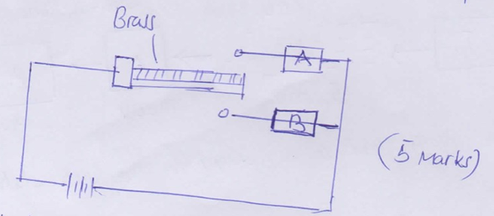

(b) Tree beakers are of identical size and shape. One beaker is painted matt black, One is dull with and one is gloss white. The beakers are filled with water.
- In which beaker will the water cool most quickly? Give a reason (3marks)
- State a process in addition to conduction, convection and radiation by which heat energy will be lost from the beaker. (2marks)
- (a) A process cooker will cook beans faster at then an open saucepan. Give explanation on those observations (5mark)
(b) An insulated cap holds of water at 0⁰С. 0.2kg of boiling water at standard pressure is poured into the cap. What will be the final temperature? (5marks)

SECTION C (25marks)
Answer two (2) questions from this questions
- (a) A boy has a large number of colored bulbs labeled 240V and 600w he washes to use for dew ration so that the bulbs operates normally. How many can be connect to a 240V and 5A fuse (4marks)
(b) You are required to use 3Ω resistor in your electric circuit. Unfortunately there are only 2Ω resistor in school Physics laboratory. How could you design the required resistor from available resistors? (4.5marks)
(b) A figure shows a block diagram of generation and distribution of electricity using a.c generator. Study the diagram then answer the question that follow.
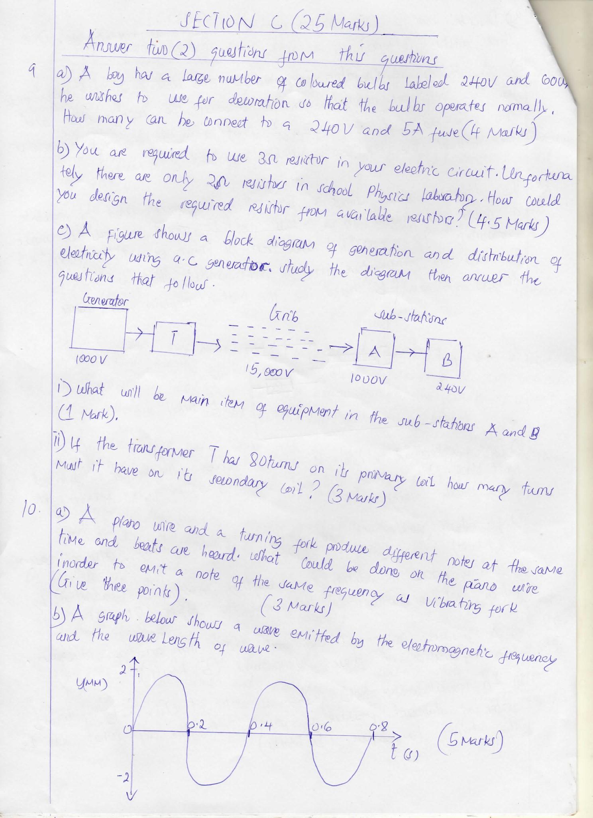

- What will be main item of equipment in the sub – stations A and B (1marks)
- If the transformer T has 80turns on its primary coil how many turns must it have on its secondary coil? (3marks)
- (a) Piano wire and a turning fork produce different not at the same time and beats are heard. What could be done on the piano wire in order to emit a note of the same frequency as vibrating fork (Give three points). (3marks)
(b) A graph below shows a wave emitted by the electromagnetic frequency and the wave length of wave.
(c) Boats use “sonar” to detect the depth of water in the sea or lakes. A sonar pulse sent out by a boat arrives back after 3 seconds. If the speed of sound in water is 1500m/s, deep in the water (4.5marks)
- (a) Why some semiconductors called “P” type and other “N” type? (3marks)
(b) Describe, how you will connect the semiconductor diode as forward bias (4marks).
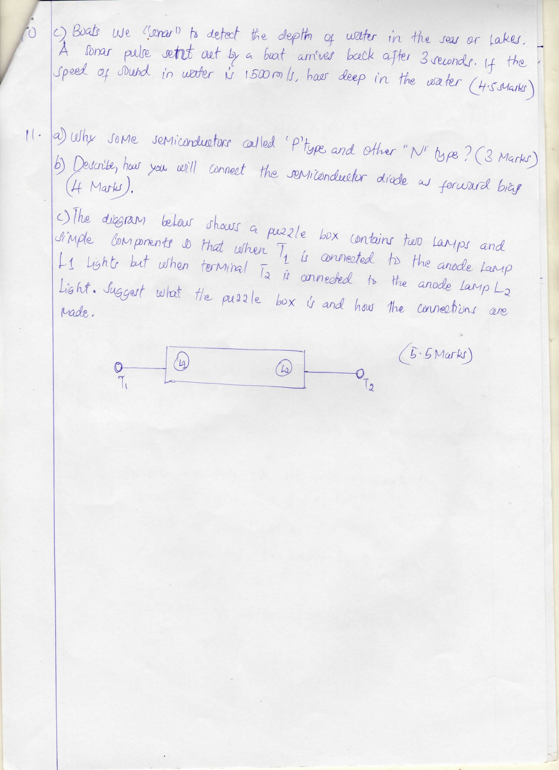
(c) The diagram below shows a puzzle box contains two lamps and simple components so that where T₁ is connected to the anode lamp L₁ lights but where terminal T₂ is connected to the anode lamp L₂ light. Suggest what the puzzle box is and how the connections are made.

