PO-RALG
MVOMERO DISTRICT COUNCIL
PHYSICS MOCK EXAMINATION
MARKING SCHEME MAY 2023
FORM IV
SECTION A (15 MARKS)
- ( 1 MARK @) = 10 marks
i | ii | iii | iv | v | vi | vii | viii | ix | x
C | E | A | A | B | E | B | A | C | A

- ( 1 MARK @) = 05 marks
i | ii | iii | iv | v
D | H | B | E | G

SECTION B (60 MARKS)
- (a) (i) The student got the problem of nose bleeding due to high blood pressure at high altitude compared to atmospheric pressure. (02 Marks)
(ii) Astronauts wear space suits in order to maintain this pressure (02 marks)

(b) Solution
Data
Weight =24500 N 0.5 marks
Gravity (g) = 10 N/Kg

- From
Weight = mg 0.5 marks
Therefore,
M= w 0.5 marks
g
= 24500 N 0.5 marks
- /kg
=2450 kg
The mass of the spacecraft is 2450 Kg. 01 marks

- The acceleration due to gravity on Jupiter’s surface in 2.6 times that on earth.
Therefore, g on Jupiter = 10 N/kg × 2.6 = 26 N/kg. 0.5 marks

From , w=mg 0.5 marks
M=2450 kg and g= 26 N/kg 0.5 marks
Therefore,
W= 2450 kg × 26 N/kg 0.5 marks
= 63700 N.
The weight of spacecraft on Jupiter is 63700 N. 01 marks

- (a) Solution
Given, incident angle (i) = 30°; angle of refraction (r) = 22°, refractive index (ŋ) = ? 01 marks
From,
ŋ = sin i = sin 30 ° 02 marks
Sin r sin 22°
= 1.33
Therefore, the refractive index of the medium is 1.33. 01 marks

(b) Solution
Diagram (03 marks)
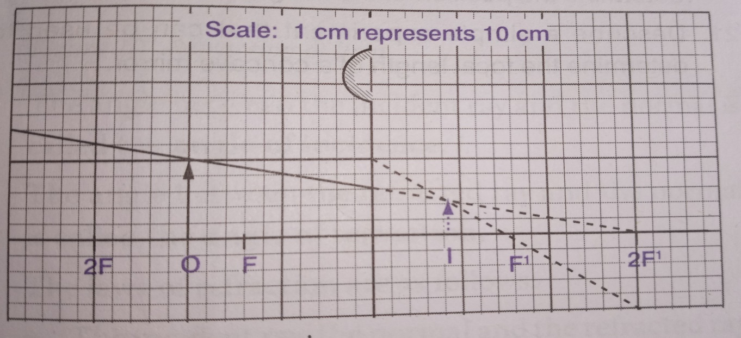
- Image distance = 0.8 cm × 10 = 8 cm. 01 marks
- Image height = 0.4 cm × 10 = 4 cm. 01 marks
- Magnification = 4 cm =0.4 or v = 8 cm = 0.4 01 marks
10 cm u 20 cm
5 (a) (i) Specific heat capacity is the quantity of heat required to raise the temperature of 1 kg of a substance by 1 C or 1 K. 01 marks
-Specific latent heat of vaporization is the quantity of heat required to convert unit mass of a substance from liquid to vapour state without change of temperature. 01 marks
(ii) -Temperature, Atmospheric pressure and Vapour pressure of the liquid 03 marks, 1 mark @
(b) Solution
m_{i} = 800 g m_{f} = ? 01 marks
n = $\frac{40 days}{8 days}$ = 5 01 marks

m_{f} = mi = 800 g 01 marks
2^{n} 2⁵
= 800 g = 25g 01 marks
32
= 25 g of the 800 g initial sample will remain undecayed after 40 days. 01 marks

6. (a) (i) Newton’s first law of motion. 01 marks
(ii) Newton’s first law of motion states that “A body will continue to be in its state of rest or uniform
motion unless an external force acts on it. 02 marks

(b) (i) Solution
Efficiency = $\frac{M.A}{V.R}$ × 100% 0.5 marks
But
M.A = $\frac{Load}{Effort}$ 0.5 marks
=$\frac{750 N}{30 N}$ = 25 01 marks
V.R = $\frac{circumference of a circle}{pitch}$ 0.5 marks
= $\frac{2× 3.14 ×1 6cm}{0. 5 cm}$ = 201 0.5 marks
Therefore, efficiency = $\frac{25}{201}$ × 100 % 0.5marks
= 12.4 %
The efficiency of the machine is 12.4 % 0.5 marks

7. (a) (i) Both consists convex lens which focus on inverted image. In camera focused onto film while human eye focused on retina (2 marks).
(ii) Both adjust the quantity of light entering. In camera it’s done with aperture while in human eye its done with iris (2 marks).
(iii) Both capture the image through an important element, retina for human eyes and film in a camera ( 2 marks).
(b) (i) Conduction of heat is the process by which heat energies is transmitted through collisions between neighboring atoms or molecules. 02 marks
(ii) Applications of conduction of heat in our daily life. 01@ = 05 marks
-Cooking vessels are made of metal to transfer heat quickly
- An insulator blocks the transfer of heat. Eg. Handles of most kettles and electric iron.
- Clinical thermometer use mercury because mercury is a good conductor of heat.
-Aluminum in some cases is used to make motor vehicles engines and other engines accessories because it can easily transfer or exchange heat from a hot engine to the environment.
-Electronic devices attached to heat sinks to protect them from overheating.

8. (a) An earthquakes is a sudden motion or shaking of the earth caused by a sudden release of energy that has accumulated within or along the edges of the earth’s tectonic plates. 02 marks
(b) –Thermal indicator
- Water indicator 01@ = 04 marks
- Seismo electromagnetic indicator
- Animal indicator
-Human indicator

(C) -Pick a safe place where things will not fall
-wait in your safe place until the shaking stops. 01@ = 04 marks
- If you are outside during an earthquakes, stay outside.
- After shaking stops, help other people around you.
SECTION C (25 MARKS)

9. (a) (i) Ohm’s law states that; the voltage across a conductor is directly proportional to the current flowing through it, provided all physical conditions and temperatures remain constant. 02 marks
(ii). –Temperature
-Length of the conductor 01@ = 04 marks
- Cross- section area
- Nature of material
(b) (i) Insulators 01.5 marks
Forbidden energy gap is small compared to that of insulators has a large value of energy. No electron can acquire such energy in order to cross the gap and enter the conduction band, therefore an insulator cannot conduct electricity.

Semiconductors 01.5 marks
Forbidden energy gap is small compared to that of insulators, as temperature change, some electrons in valence band acquire energy greater than the forbidden energy gap, the electrons become free to conduct electricity and hence the material becomes a conductor.

Insulators 01.5 marks
In conductors, no forbidden gape. This cause small energy is required to transfer electrons from the valence band to the conduction band. Such energy can be obtained even at very low temperatures; hence metals are good conductors of electricity.

(ii) In DC generator, the electrical current flows only in one direction. In an AC generator, the coil through which the current flows is fixed while the magnet moves. 02 marks

10. (a) When the length of a string is changed, it will vibrate with a different frequency. The shorter strings have higher frequency and therefore higher pitch. 02 marks
(b) Solution
Given
Length = 75 cm = 0.75 m
Mass of string = 8.2 g = 0.0082 kg 0.5 marks
Tension of the string = 18 N

From
µ = $\frac{M}{L}$ = $\frac{0.0082}{0.75}$ = 0.011 Kg/m 01 marks

then,
V = $√\frac{T}{M}$ = $√\frac{18}{0.011}$ = 40.5 m/s 01 marks
From
F_{n} = $\frac{nV}{2L}$ 0.5 marks
First harmonic, n=1 so
F₁= $\frac{v}{2L}$ = $\frac{40.5}{2 X 0.75}$ = 27 Hz 01 marks

Third harmonic,
F₃ = $\frac{3v}{2L}$ = $\frac{3 X 40.5}{2 X 0.75}$ = 81 Hz 01 marks
The first harmonic = 27 Hz 0.5 marks
The third harmonic = 81 Hz 0.5 marks

(c) Solution
Given
V_{p} = 240 V V_{s} = 12 V 0.5 marks
Np = 600 turns N_{s} = ?

From $\frac{NP}{NS}$ = $\frac{VP}{VS}$ 01 marks

$\frac{600 turns}{NS}$ = $\frac{240 V}{12 V}$ 01 marks

N_{S} = $\frac{12 V}{240 v}$ x 600 turns 01 marks

= 30 turns
Therefore, the number of turns in secondary coil is 30. 01 marks

11. (a) In P-type semiconductors the majority charge carrier are holes which are positive WHILE in N-type semiconductors the majority charge carriers are electrons which are negative that’s why are some semiconductors called P-type and others N- type ( 3 marks).
(b) A semiconductor diode is connected as forward bias when the anode (positive terminal) is connected to P side and Cathode (negative terminal) in N-side of the PN junction of the diode (3 marks)

(ii) Solution
Upthrust in water = W_{o} – W₂ = 8.6 N – 5.4 N = 3.2 N 0.5 marks
Upthrust in liquid = W_{o} – W₁ = 8.6 N – 6.0 N = 2.6 N 0.5 marks

By Archimedes’ principle
Upthrust = weight of the displaced fluid
Note, 1 g = 0.01 N
Mass of displaced water = $\frac{w}{g}$
= $\frac{3.2}{0.01}$ g = 320 g 01 marks
Volume V of water displaced = $\frac{260 g}{1 g/cm3}$ = 260 cm³
Hence, the volume of liquid displaced is 260 cm³ 01 marks

Mass of liquid displaced = $\frac{w}{g}$= $\frac{3.2 N}{0.01 N/g}$ = 320 g 1 marks

Then, Density of liquid = $\frac{m}{v}$ = $\frac{320 g}{260 cm3}$ 1.2 g/cm³ 1 marks

Relative density of liquid = $\frac{density of liquid}{density of water}$ = $\frac{1.2 g/cm3}{1.0g/cm3}$ = 1.2 01 marks

Relative density of liquid = 1.2 (0.5 marks)

