PRESIDENT’S OFFICE
REGIONAL ADMINSTRATION AND LOCAL GOVERNMENT
KAHAMA MUNICIPAL
FORM FOUR PRE-MOCK EXAMINATIONS
022 LITERATURE IN ENGLISH
TIME: 3:00 HOURS
INSTRUCTIONS
- This paper consists of section A, B and C
- Answer all questions in section A and B and three (3) questions from section C
- Section A carry 15 marks, B carry 40 marks and section C carry 45 marks.
- Cellular phones are not allowed in the examination room.
- Write your Examination Number one very page of your answer booklet(s)/sheet.
FOR EXAMINER’S USE ONLY
QN/NO | ATTEMPTED | MARKS | INITIALS OF EXERMINERS
1
2
3
4
5
6
7
8
9
10
TOTAL

SECTION A (15 Marks)
Answer all questions in this section
1. For each of the items (i) – (x), choose the correct answer from among the given alternatives and write its letter beside the item number in the answer booklet provided.
- The following statements are true about Short stories except.
A. It can be read from the beginning to the end without stopping.
B. It focuses on one or many main characters that face a single problem or conflict.
C. Characters are usually not fully developed.
D. It usually centers on one idea or subject.
E. It has a simple plot.
- The definition of literature is not complete unless it involves the following elements.
A. Art, language, audience and conflict.
B. Art, language, audience (society).
C. Art, language, society and relevance.
D. Art, themes, messages, and language.
E. Art, society, philosophy.
- “The son of an English teacher fails an English Exam”. This statement best explains;
A. Verbal irony.
B. Dramatic irony.
C. Satire
D. Situational irony.
E. Sarcasm
- This is a sombre song or lament expressing mourning or grief, such as would be appropriate for performance at a funeral.
A. Ballad
B. Fairly tale
C. Epic
D. Dirge
E. A freedom Song
- Angel was watching drama that was full of serious actions and scenes that made her sad and at times it had humorous scenes that made her laugh. Finally it ended happily. Angel was watching:-
A. A comedy drama
B. A tragedy drama
C. A Melo drama
D. A historical drama
E. A tragic-comedy drama
- Which of the following expressions best explains a fable;
A. It is a brief story about an interesting, amusing or strange event.
B. It is a fictional tale that explains the actions of gods, or heroes.
C. It is a song-like narrative poem that tells a story, often one dealing with adventure and romance.
D. It is the story in which the main character dies.
E. It has animal characters and teaches a moral lesson.
- Joshua was reading a novel and he came across this statement; “Christianity shone like a beacon in the black night of paganism”. Which term best describes that statement?
A. Metaphor.
B. Simile.
C. Satire.
D. Personification.
E. Rhetorical question.
- This image is an example of:
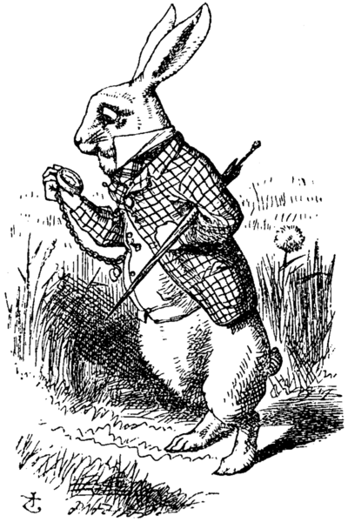
A. Personification.
B. Anthropomorphism.
C. Zoomorphism.
D. Irony.
E. Simile.
- You are writing a story and you begin by showing the funeral of a man who is dead, then in the middle you show how he grew up when he was young until he graduated, you finish by showing how he got the accident that caused his death. How do we call the plot you have used?
A. Foreshadowing plot.
B. Flash-forward plot.
C. Flashback plot.
D. Chronological plot.
E. Resolution plot.
- One of the following arrangements describes the order of conflict development in the plot of a literary work.
A. Exposition, Falling Action, Climax, Rising Action, Resolution.
B. Exposition, Rising Action, Falling Action, Climax, Resolution.
C. Exposition, Climax, Rising Action, Falling Action, Resolution.
D. Exposition, Rising Action, Climax, Falling Action, Resolution.
E. Exposition, Rising Action, Climax, Resolution, Falling Action.
- Match the descriptions in List A with the corresponding type of item in List B by writing the letter of the correct response beside the item number in the answer booklet provided.
LIST A | LIST B
- This is a work of fiction that is longer and more complex than a short story and it has more than forty thousand words  - This is a fiction work that is longer than a short story but shorter than a novel.  - This is a short novel, typically one that is light and romantic or sentimental in character.  - This is a story usually about imaginative characters and events that is short enough to be read from the beginning to the end without stopping.  - This refers to any kind of writing that is not poetry or that is not presented in verse form or stanza. | - Prose fiction  - Short story  - Novelette  - Novella  - Novel  - Autobiography  - Drama
SECTION B (40Marks)
Answer all questions in this section
- Imagine that you have gone home for the holiday and you meet your friend who is studying PCB at Tabora boys High school. You tell him that you are studying Literature in English and he says you are wasting your time. Prove his wrong by using five points.
- ______________________________________________
______________________________________________
- ______________________________________________
______________________________________________
- ______________________________________________
______________________________________________
- ______________________________________________
______________________________________________
- ______________________________________________
______________________________________________
- Read the following poem and answer the questions that follow.
I TOO SING AMERICA
(Langston Hughes)

I, Too Sing America.

I am the darker brother
They send me to eat in the kitchen
When company comes,
But I laugh,
And eat well,
And grow strong.

Tomorrow,
I’ll sit at the table
When company comes.
No body’ll dare
Say to me,
‘Eat in the kitchen’,
Then.

Besides,
They’ll see how beautiful I am
And be ashamed –

I, too, am, America.

QUESTIONS
- What type of the poem is this? Give reason.
- Who is the persona and how do you know?
- What is the tone and mood of the poem?
- Comment on the structure of the poem.
- What does the line “They send me to eat in the kitchen” symbolize?
- Differentiate the following terminologies as used in literary works.
- Anthropomorphism and zoomorphism.
- Euphemism and vulgarism.
- Metaphor and simile.
- Symbolism and imagery.
- Synecdoche and anecdote.
- Study the following extract of picture of an actor from the drama of the Magic then answer questions below.
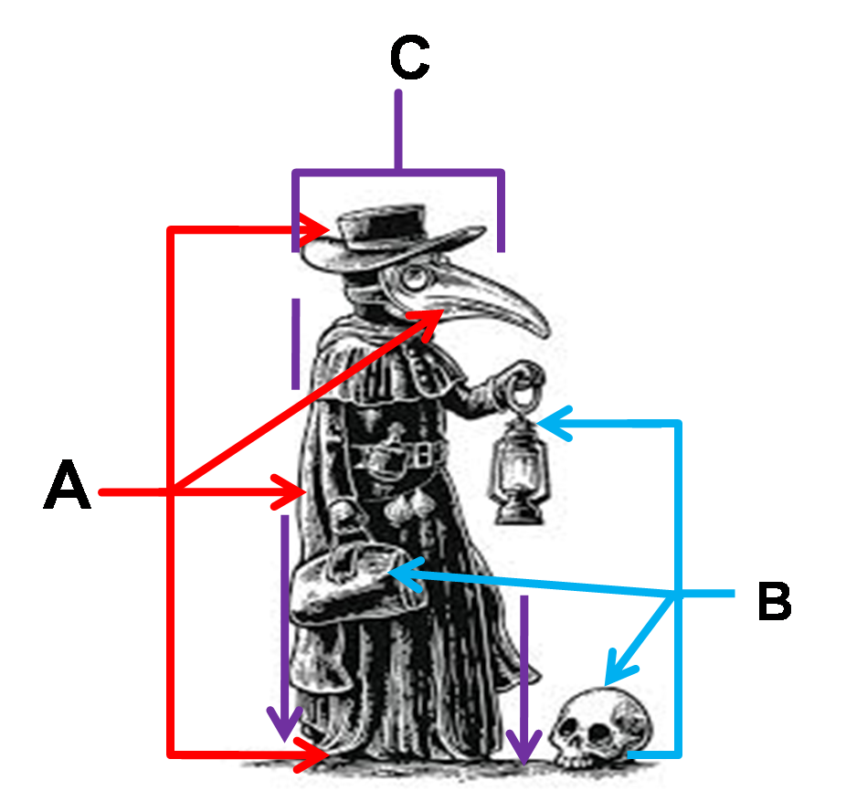
QUESTIONS
- Label the following letters as indicated above in reference to drama;
- ________________________
- ________________________
- ________________________
- What is A? ________________________________________________________________________________________________
- What is B? ________________________________________________________________________________________________
- What is C? ________________________________________________________________________________________________
- Which major theme represented by a person labelled C?
________________________________________________________________________________________________
SECTION C (45 Marks)
Answer three (3) questions from this section.
Answer question 7 and 8 and choose one (1) from either 9 or 10
LIST OF READINGS
Plays
The Trials of Brother : Jero Wole Soyinka
Dilemma of a Ghost : Ama Ata Aidoo
The Lion and the Jewel : Wole Soyinka
The Government Inspector : N. Gogol
Novels
A Walk in the Night and Other Stories : Alex La Guma
Houseboy : Ferdinand Oyono
The Concubine : Elechi Amadi
The Old man and The Medal : Ferdinand Oyono
Poetry
Selected poems : Tanzania Institute of Education
Growing up with poetry : David Rubadiri
- Sometimes a literary artist takes the role of a teacher by educating the society on different matters. Using two plays you have read justify the above statement. Give three points from each play.

- The African continent has a long way to go to attain development because of bad leadership. Choose two poems you have read and appreciated to prove the above statement. Three points from each poem.

- A novelist is a historian who documents the history of a particular society. Using two novels you have read support this view by showing how the content of the book is a product of real history. Give three points from each novel.

- Choose any two protagonists from two different novels and show why you sympathise with them.

