THE REGISTERED TRUSTEES OF BUHONGWA ISLAMIC CENTER

BUHONGWA ISLAMIC SECONDARY SCHOOL

FORM THREE (III) MIDTERM EXAMINATION

013 GEOGRAPHY
TIME: 3:00 HOURS AUGUST, 2025

INSTRUCTIONS
- This paper consists of sections A, B and C, with total of Eleven (11) questions.

- Answer all questions in section A and B and any Two (2) questions from section C.

- Section A carries Sixteen (16) marks, section B fifty Four (54) and section C carries Thirty(30) marks.

- Map extract of MVOMERO (Sheet 33/1) is provided.

- Programmable calculators, cellular phones and any unauthorised materials are not allowed in the examination room.

- Write your Examination Number / Name on every page of your answer sheet.

SECTION A (16 Marks)
Answer all questions in this section.

- For each of the items (i – x), choose the correct answer from among the given alternatives and write its letter in the answer booklet (s) provided.

- People of Kagera Region are good example of Victims of Earthquake incidence. Can you identify in which year that incidence occured?
- 2020
- 2015
- 2019
- 2016
- 2018

- The Tanzania Meteorologists announced the temperature of Morogoro100m above the sea level is 33℃, What will be the temperature of Dodoma 800m above sea level?
- 37.4℃
- 32℃
- 24.8℃
- 4.2℃
- 28.8℃

(iii) Sir. Zacharia is a geography teacher. What is the type of human activity done by him among the foollowing
- Teaching
- Primary activity
- Secondary activity
- Tertiary activity
- Quaternary activity

- Mobutu visited the Indian ocean, in the ocean he sawa the coast, shore, and ocean floor. Do you think which minerals make ocean floor?
- Silica and Calcium
- Silica and Aluminum
- Iron and Nickel
- Silica and phosphate
- Silica and magnesium

- Salma is a university student who conducted her research in the societies where the areas are occupied by water that resulted to the lack of land for Agriculture and settlements. Which method should be advised the societies to overcome the challenges?
- Land conservation
- Plantation method
- Land reclamation
- Agro-forestry method
- Land policy method

- Which among the following are not the outcome of mining to environment?
- Provide employment
- May lead to deforestation
- Improves the social services
- May lead water pollution
- A and C

- The elements of soil are very crucial for soil itself and other organisms. Identify the most correct list of soil elements:
- Soil water, soil air, organic matter, and humus
- Humus, inorganic mater, soil air and soil water
- Organic matter, inorganic matter, soil air and soil water
- Organic matter, soil profile, soil air and soil water
- Organic matter, inorganic matter, soil Ph and soil colour

- All form three girls from BISS last year travelled from Tanzania to South America and they passed across the International Date Line on December,29th, Wedensday. On Which day did they reach in South America?
- December, 29th, Thursday
- December, 27th, Wednesday
- December, 28th, Tuesday
- December, 30th, Thursday
- December, 28th, Wednesday

- Mount Kilimanjaro and Mount Elgon are the pride of Africa. What is the mode of formation of those mountain?
- Rift valley process
- Volcanic eruption
- Compression force
- Earthquake
- Deposition of sediments

- Miriam visited around rift valleys, where she saw it is very steep and narrow. Can you tell her, how that feature is formed, among the following:
      - By tensional force and downward movement of the central faulted layers
      - By compression force and downward movement of the central faulted layers
      - By tensional force and sideward movement of the central faulted layers
      - By tensional force and horizontal movement of the central faulted layers
      - By tensional force and human activities along a central faulted layers

2. Match the descriptions of different intrusive vulcanic features in LIST A with the correct feature in LIST B by writing the letter of the correct response beside the item number in the answer booklet (s) provided.

 | LIST A |  | LIST B
 | - Cooled and solidified forming wall like structure across rock layers  - Cooled and solidified forming table like structure across rock layers.  - Cooled and solidified forming mushroom like structure.  - Cooled and solidified forming Saucer like structure.  - Cooled and solidified forming dome/hill like structure.  - Cooled and solidified forming series of rocks along Anticlines and syncline along young fold mountains. |  | - Dyke  - Batholith  - Phacolith  - Sill  - Laccolith  - Lopolith  - Volcanic plug  - Block mountain  - Acidic lava cone

SECTION B (54 Marks)
Answer all questions in this section
3. Carefully study the map extract of MVOMERO (Sheet 163/4) and then answer the following questions:
- Compute the area covered by Lake Balangida in Km Squares
- With one (01) evidence, explain how you see the population distribution in Mpwapwa
- With evidences, suggest four (04) economic activities that you can engage in Mpwapwa.
- By pointing the grid reference,, identify the part of the map which is the highest point of all.
- What are the three (03) methods used to represent relief on the map/

4. Study carefully the following data about exportation of minerals from Tanzania to Hongkhong - China in tones and answer the questions that follow;

MINERALS | QUANTITY IN TONNES
GOLD | 950
COPPER | 760
DIAMOND | 800
TANZANITE | 1500

QUESTIONS
- Present the data by Plotting A SIMPLE BAR GRAPH

- Write two (02) advantages and two disadvantages of using that method in (a) above.
- Comment on the exportation of the minerals
- Apart from the Simple bar graph, mention other three (03) graphs that can be used to present the data above.

5. After completing Survey topic, your geography teacher gave you a task of taking linear measurement of the girls assembly area.
- What type of survey is going to apply?
- Draw and explain the functions of the five (05) survey tools you will use that survey.
- What are three importance of that survey you have done to our school?

- Underground water is very important to our life. Explain types of underground water and explain the five (05) values of underground water.
8. Carefully study the photograph below then answer the questions that follo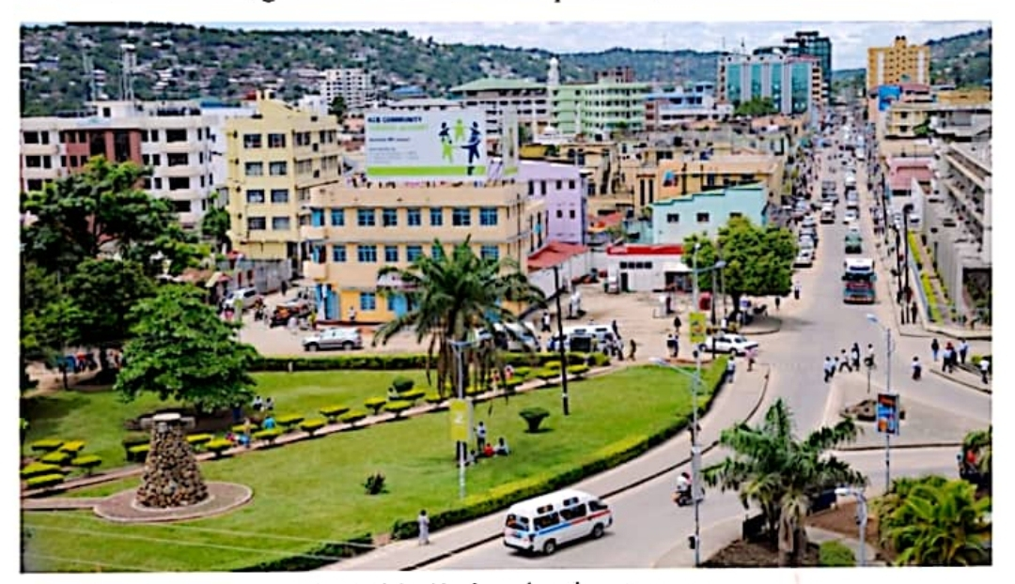QUESTIONS
- Using(02) two evidences you have seen, name the type of photograph
- With evidences from photograph, write three (04) economic activities that can take place on the area
- Using (02)two evidences you have seen, what time was the photograph taken.
- What was the position of the camera man, when he/she was takingthat photograph?
8. Atmosphere is impprtant to you and other organisms. With well labled diagram of atmosphere, explain five (05) importance of atmosphere in our life.

SECTION C (30 Marks)
Answer any two (02) questions from this section.
9. Act as the manager in GSM TILES MAKING INDUSTRY. Advise your fellows on which factors should be considered when a person wants to establish any industry. Use six (06) points.
10. Earthquake happens in our environment.
- Describe five (05) effects of Earthquake
- Describe three (03) ways to protect yourself during earthquake.

11. Assume that you have been invited by Village Executive Officer of Mbabane village as a main speaker in the village meeting, purposely to talk about the ways which should be done for conserving our environment. Use Six (06) points that you will use in your speech in front of the villagers.

